**Practical 5**

**Aim:**

**Controlling Raspberry Pi with Telegram.**

**Additional Hardware Required:**

1. LED
2. Breadboard
3. Resistor
4. Jumper wires

**Software required:**

On Mobile Phone: Telegram

**Steps**

**1: Download Telegram from playstore on your android phone.**

**2: Install Telegram.**

**2: Open Telegram app in your system or mobile**

**3: Click On Start Messaging Button**

**4: Enter your mobile number to register with telegram service.**

**5: Search for name "BotFather"**

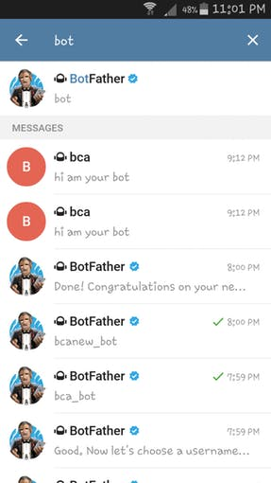

**6: Click on "BotFather**

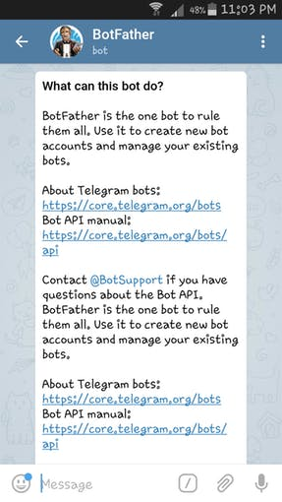

**7: To Start "BotFather" type /start in message**

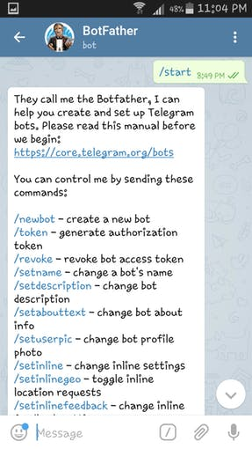

8: Now type /newbot in message . and then give name to your BOT and Username also.

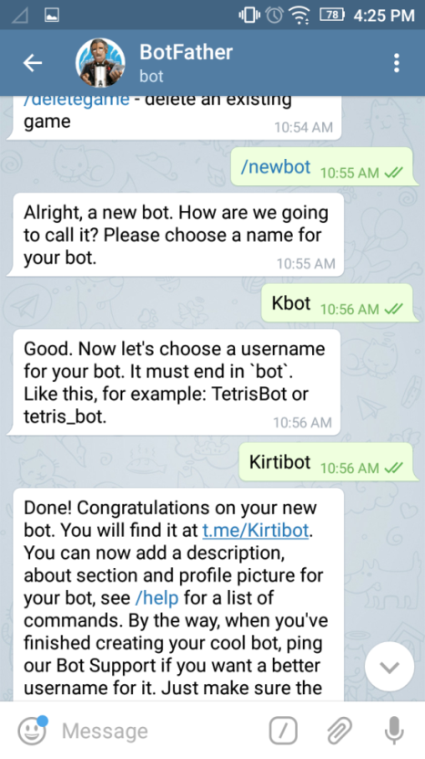

9: **Obtain access token**

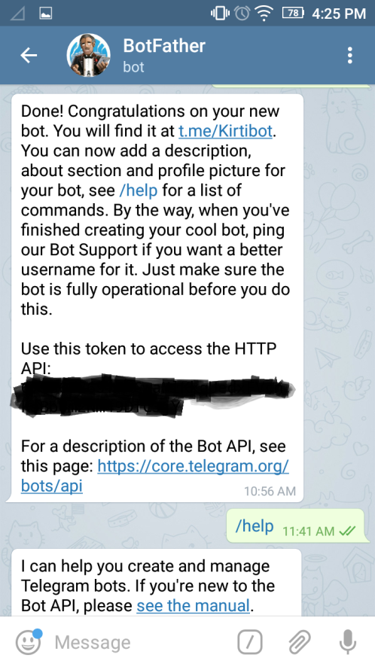

This same token we are supposed to use in our code in raspberry pi to connect to our BOT.

**Set up On Raspberry Pi:**

**1: Install "Python Package Index" and Telepot using :**

python3 -m pip config set global.break-system-packages true

sudo apt install python3-pip

pip3 install telepot

**2: Test your bot using python3 IDLE and type:**

import telepot

bot = telepot.Bot('Bot Token')

bot.getMe()

If it prints your bot details means everything is correct.

If not then token is wrong.

**Write the following code in Pyhton 2 IDLE and save it as ‘mybot.py’**

import sys

import time

import random

import datetime

import telepot

import RPi.GPIO as GPIO

GPIO.setmode(GPIO.BOARD)

GPIO.setup(11, GPIO.OUT)

def handle(msg):

chat_id = msg['chat']['id']

command = msg['text']

print 'Got command:', command

if command == 'on':

bot.sendMessage(chat_id, "LED on")

GPIO.output(11,GPIO.HIGH)

elif command =='off':

bot.sendMessage(chat_id, "LED off")

GPIO.output(11,GPIO.LOW)

elif command == 'stop':

exit()

try:

bot = telepot.Bot('Bot Token')

bot.message_loop(handle)

print 'I am listening...'

while 1:

time.sleep(10)

except TelegramError:

print ' '

Note: do not forget to replace ‘Bot Token’ with your token received from telegram.

**Output:**

Connections:



Output on python IDLE:

Output on Telegram (Mobile phone):

